VARDHAMAN PARK CO-OP. HOUSING SOCIETY
Shahad – Mohone Road, Shahad (W) Kalyan 421301
SOCIETY MAINTENANCE CHARGES BILL FOR THE MONTH OF APRIL 2021
Bill No. | 204 | Bill Date | 7-Nov-26 | Name | VIRENDRA VERMA
Bldg | B-3 | Flat No. | 604 | BHK | 1 BHK | Flat Area | 708

Sr.No. | Description | Amount
1 | *Service charges | 1659
2 | **Water charges @ Rs.45 per tap | 225
3 | Sinking fund @ 0.25% of Rs.450/- | 66
4 | Repair fund @ 0.75% of Rs.450/- | 199
5 | Building insurance @ 0.40 per sq ft. | 24
6 | Emergency fund @ 25/- p.m | 25
7 | Parking charges | 0
8 | Total maintenance charges | 2198
9 | ***Sub-letting charges if any | 166
10 | Unpaid maintenance charges of previous months | 0
11 | Interest payable @18% per annum (compounding interest) | 0
12 | Advance paid in previous month | 0
13 | Total charges payable for the month – (8) to (12) | 2364
----This is computer generated bill and hence does not require signature----

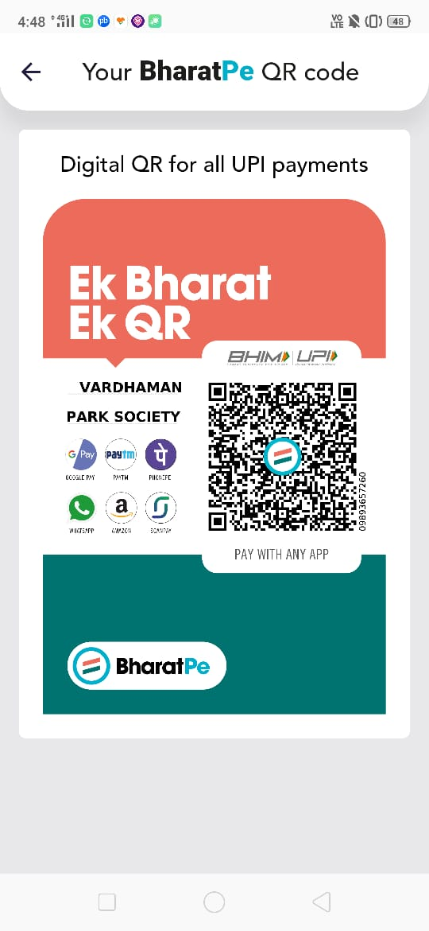
Q
R

C
O
D
E
Bank Name | Bank of Baroda
Bank Account No. | 76010100003462
Account Name* | Pandurang Nandanwar or Chandsingh Devisingh Khinchi or Manoharlal Boduram Saini
IFSC Code | BARB0VJTHAW
MICR Code | 400012341
Note:
- *The service charges are calculated on per flat basis i.e total expenses (excluding water) divided by 95 flats.
- **Water charges per tap is calculated @ total water expenses divided by total taps.
- ***Sub-letting charges (on rented flats) is calculated @ 10% of *Service charges.
- You are required to pay the charges by 10th of every month. However, there is a grace period till 30th/31st of the month for IMPS/NEFT/RTGS mode of payment and in case the amount is not paid then interest @18% p.a (compounding interest) shall be levied on the outstanding amount from the date of due. Example- Outstanding Amt X 18% / 12.
- Due date for cheque payment is 25th of month and if there is delay beyond one month then interest @ 18% per annum shall be charged.
- You are requested to share the payment proof on Whats app ONLY to Nitesh Medh - +91 8976839260 and Sagar Ghule - +91 7506254580.
Previous Payment Details
Particulars | Dec-20 | Jan-21 | Feb-21 | Mar-21 | Apr-21 | May-21
Amount | 2124 | 2364 | 2364 | 2364
Date | 1/23/2021 | 2/19/2021 | 3/23/2021 | 4/14/2021
Mode | IMPS | IMPS | IMPS | IMPS

